**Weekly Report 11/4**

**MSiA-400 Group 1** : Ellen, Henry, Ishu, Enzo

Tasks Accomplished:

* Finalized the business question for the project
  + Store clustering: how can we cluster the stores into different groups, for valid performance comparisons and benchmarking?
* Outline the future plans as shown below.

1. Finish data cleaning and join the tables together into one within 2 weeks
2. Spend one week to determine the parameters/features for the model (potential ones include ‘location’, ‘brand/tier’, ‘sales’, and etc)
3. Build different models and test which model performs the best
4. Get clusters, analyze, and write the final report

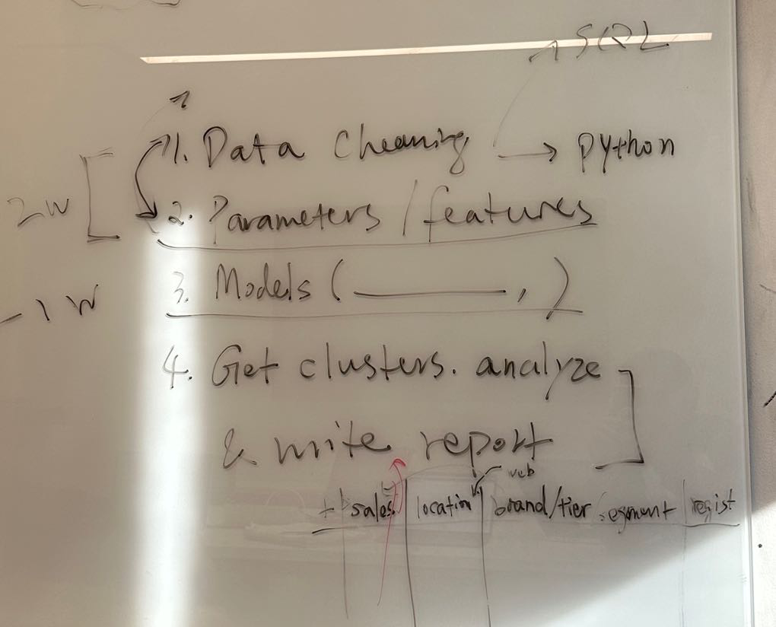

Plans for Next Week:

1. Continue data cleanning and join the tables once finished.
2. Further exploratory data analysis and think about the potential parameters and features that is helpful for the business question.